Square Dance
- A good, lively start to a session that introduces and develops the fundamentals of dribbling.
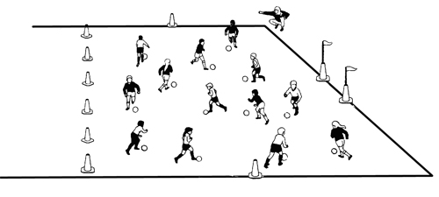
- Mark a square approximately 10-15 yards x 10-15 yards, depending on numbers.
- Each player should have a ball.
- This area provides the template for many of the activities in the session (see Dribble Through the Jungle Run, North & South, etc.).
- Set different challenges, but only one at a time, e.g.
  - "STOP" Put foot on top of ball quickly and freeze like a statue.
  - "GO" Move right or left with the ball, fast, for three or four yards.
  - "TURN" Quickly turn 180 degrees with the ball, moving three or four yards.
- Encourage players to keep the ball close to their feet.
- Encourage players to keep their heads up while playing.
- To avoid giving players too much information at once, introduce instructions one at a time (over more than one session) and incorporate practice time between.
- Don’t be afraid to incorporate your own ideas.
  - Each time you shut “Change!” children must change direction or change from right foot to left.
  - Shout a number and the kids must do that many toe touches
  - Shout a body part and the kids must stop the ball with that body part – make sure you tell them to start dribbling again as some may just stay in that position.

Dribble through the Jungle
Organization
- Make an area using marker disks, cones, etc.
- One ball per Child.
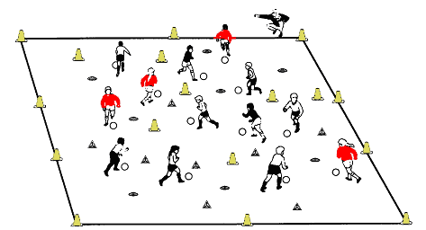
Games and variations
- All the Children must dribble the ball through the jungle without touching a tree (poisonous).
- They may be chased by lions, tigers or elephants (coaches).
- They can "clear" the jungle by knocking down the cones with the ball (Knock the Jungle Down)
- Cones are poisonous and cannot be knocked down with feet...only by kicking the ball against the cone.
- Later reforest the jungle by putting the trees (cones) back up (Reforest the Jungle), using only our feet (seedlings/non-poisonous!) and not our hands (little bit poisonous!). Use your imagination to spark the imagination of the Children.

Swamps, Rivers, Jungles and Quick Sands
- It is much more exciting to be sending the ball (a bird, a plane, a rocket) across a swamp, a river, over quicksand or through a jungle, than kicking a ball from one line to another.
- Drawing on the imagination of the Children, we can motivate and excite them to perform the skills of soccer for fun, while developing the fundamentals and understanding of the game.
Here are some ideas:
- River Ball
- Through and Over the Jungle
- Across the Swamp
- Avoiding the crocodiles
- Over quicksand

- Throwing the ball, over the river or quicksand will help their distribution from a goalkeeping perspective. The player on the opposite side must control the ball without using their hands.
- Place coaches in the middle to be real swamp animals that the kids have to kick the ball past.
- Place cones in the middle for the players to hit (hurt the animals) or avoid (kick your friend the ball safely).
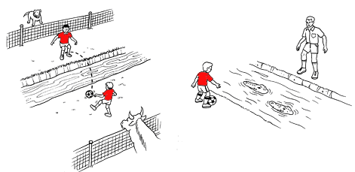

Downtown Cruising
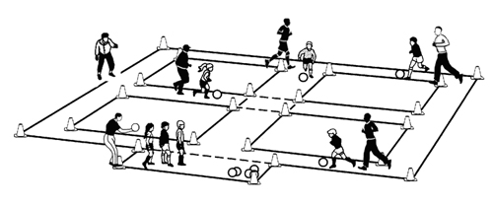

- The children are accompanied by another player as the back-seat driver (guide).
- When they reach the center of town it is a 4-way stop. The “driver’ must put their foot on the ball and indicate which way they are going.
- If the Traffic Cop (the Coach) blows his whistle everyone must stop as quickly as possible and two blasts of the whistle means they must reverse to the next road or turn and divert forwards in another direction.
- No need to make the downtown area as “organized” as this (might need 200 disks! Just joking!), but give them some parameters with whatever you have at your disposal.
- At the end we close off the downtown area for the Indy 500 with the cars racing around the outside road.
- At first give them several practice runs and then we are racing (but with no winners, remember!).
- Anyone going off the track can quickly get back into the circuit with two “Magic Toe Touches.
- Remember to sent them round the track both way – counter-clockwise encourages right foot turns and very importantly, clockwise encourages left foot turns.
- With number over three or four pairs make the Parking Lot (the Pits) much bigger than show here to allow easier entry and exit.
- Progression: Have the players dribble downtown with different “Magic Skills” – use the bottom of your foot to go forward or in reverse (backwards), use the laces of the shoe and at the intersections they must stop the ball and tap it back and forth between their feet 4 times before continuing forward.

North & South & Red & Blue
How to Play:
- North and South goals; or red, blue, yellow, greens zones marked by cones and pinnies.
- On shout "North!" all players inside the grid should dribble or pass/shoot ball through the "North" goal and wait outside square until all players have "scored." Explain what a goal is. Yellow go over the line to the yellow zone.
- Mix it up, but not too much or the children will get “mixed up!”
- Progression (second time you play the game) : “South!” – go through South goal, around the square to reenter at the North Goal
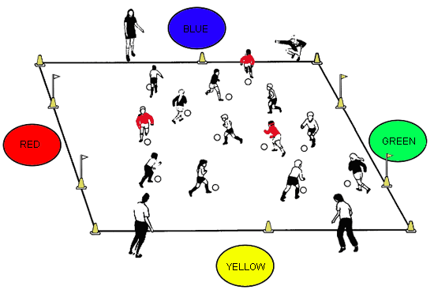

Bowser Wants the Ball
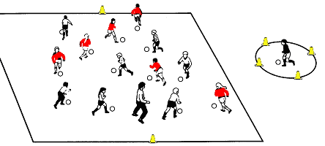
- This is a variation to the Square Dance, Jungle Run, North & South, etc.
- Here the Coach announces that he (or his/her designated person) becomes the “dog” who wants to steal any ball he/she can.
- The idea is that the children are encouraged to put their body between the “dog” and the ball to prevent the dog from gaining possession. You can demonstrate how to shield the player as our two are in the graphic below.
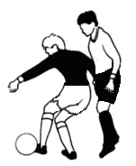
Demonstrating the skill of screening
- This is called “screening” or “shielding” and is a much used skill in the game.
- However, if you as the “dog” do steal the ball, you had better give it back very quickly or there may well be tears or bruised shins if they start kicking for the ball back. So please use discretion and most times threaten to steal the ball rather than actually take it.

Relays With and Without the Ball

Players young and old always enjoy the challenge and fun of relays. It is an old standby, but it works. While winning and losing should be downplayed most children enjoy a relay challenge, but make sure the “winning” aspect is not overdone at the younger ages.
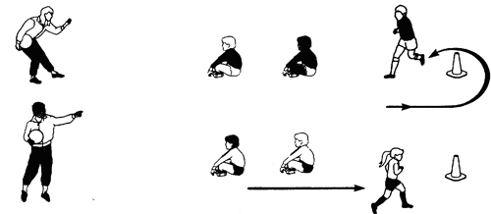

- Use a variety of relays.
- Give a point for each success. For a tie or close to a tie – a point each.
- Team scores are what counts. Make sure you keep the score or get your assistant (or parent) to keep the score.
- Try to keep numbers per relay group to two or three (maximum) – for greater activity.
- Dream up any number of relays – in and out of cones; in and out of players sitting down; 360 degrees around a cone; race to place ball on line, touch the next player and they have to retrieve it, etc., etc., etc. There is no limit to the various relays you can come up with.

- Circle Game

- A fun circle practice that develops accurate kicking.
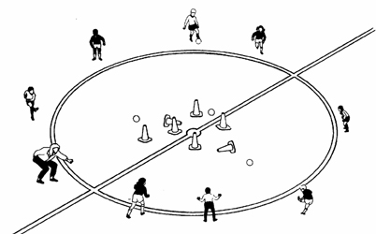
Organization
- Mark a circle having a center mark (Use marker disks to make a circle).
- A center circle works well, but regulation size will be too big for young players.
- 5-yard radius for 6-year olds; 6-yard for 7-year olds, etc.
- Each player on one side of the circle has a partner directly opposite.
- Each pair has one ball between them. If there is an odd number the coach joins in.
- One player passes the ball towards his or her partner, while trying to knock over a cone.
- The partner retrieves the ball and returns the pass, again trying to kick over a cone.
- The ball must be passed from outside the circle.
- The game is stopped when all cones are knocked down.
Teaching points
- Encourage the players to use pace as well as accuracy of pass.
- Suggest they continue to kick towards the cone even after they have actually kicked (follow through).
- Encourage them to approach the cone at a slight angle to the direction they are kicking (45 degrees).
- Condition them for some part of the practice to use their non-dominant foot only.
Progression
- Reduce the number of cones and/or make the circle bigger. Or use one cone and pairs then compete against other pairs, e.g., "First Pair to score 5 hits between them"
Target
- The coach uses a stopwatch to set the "team" record of knocking all cones down.

Pendulum Roll
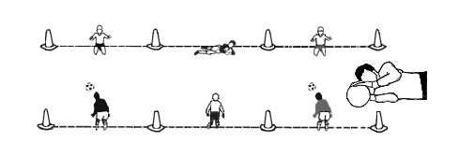
- Set out goals facing each other 3-yards apart.
- Two goalkeepers per area – better parent and child than two children together.
- Toes touching goal-line the imaginary goal line.
- Balls must be rolled along the ground to the side of each keeper.
- Hands and arms should be pushed reach forward, palms towards ball, to stop ball in front of body (see graphic).
- Ideally hands/arms should relax into a "crooked" position as the pace is taken off the ball.
- Upper knee should be drawn in comfortably across the body as the ball is received.
- Lower leg should remain loosely trailing.
- Head and upper shoulder should be drawn over and above the height of the ball.
- The ball is “trapped” by the upper hand on top of the ball and lower hand behind the ball and so uses the ground as the so-called "Third Hand" (see graphic above).
- Don’t get too concerned by the techniques so long as Parent & Child working together do a bit of rocking and rolling
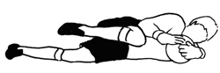
Final side-diving position as ball is pulled into the body

Roll & Catch and Shoot the Goalkeeper
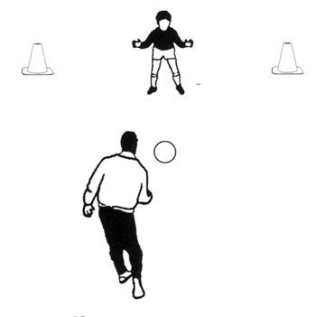
- Roll, throw or kick the ball, but in a way to give the keeper a good chance of saving the ball.
- Try to make sure the rollers are not overly exuberant.
- Serve the ball on the ground or in the air.
- They should try to kick/roll/throw the ball to the side of the child.
- Encourage the children to glide sideways (see graphic).
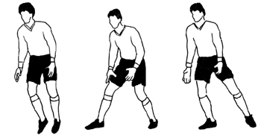

Through the Cones

Similar to knock the cones down, but this challenge requires a more measured and not so heavily weighted pass
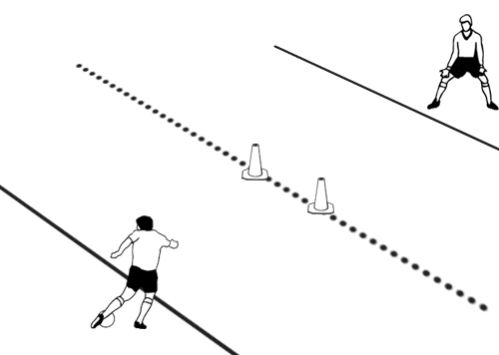

Variations/Progressions
- Wider cones for younger players, smaller for older players.
- Short distances for younger players, longer for older players.
- Left foot only (for righties), right foot only for lefties.
- Moving ball - two touch - alternate each time. Touch with left, pass with right. Touch with right, pass with left.
The Challenge
- With young players how many can we score between us with 20 passes? Then can we beat the record?
- With older players, all out war! Who can be the first to score 10 (etc.)?

Principles of Play

This month with Steve Spence setting the scene on Principles of Play with his "systems" article and with our previous "Principles" article (Newsletter April 2007 ) our practices will highlight and help develop these very important components of team play.
For our younger players 3v3 including a goalkeeper - our Micro Soccer® game - is a great place to start. Just make sure you have an "equal time in goal" rule for all players.
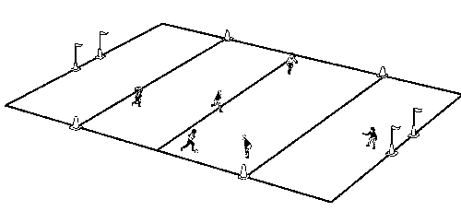

The great advantage of having a goalkeeper, apart from introducing young players to this vital and fun part of soccer, is that the keeper becomes the rear supporting player (Depth and Support in Defence). At the youngest ages the concept of defensive support is a difficult one to grasp.
However, when they are ready (8 or 9 years of age) in practice play 3 v 3 without a goalkeeper - with narrower goals.
Organization
- Field size 20 x 30 yards.
- Six-yard "boxes," marked by cones or lines, within which each designated goalkeeper may handle.
- Center line marked by cones/lines.
- Each player takes a turn in goal for three minutes maximum.
- When ball goes out of play, game is restarted by:
Sideline - throw-in (or kick-in)
End line - goal kick or corner kick, depending on which player last touched ball.
- After a goal, re-start goal kick from 6 yard line. Opponents must retreat a minimum of 5 yards (same with a kick-in).
- In practice with numbers greater than six, either have two 3 vs. 3, or if less than 12, have separate practice operating and rotate players in and out of the 3 vs. 3 game.
Coaching Points
- Encourage at least one player to go fully wide on goal kicks or when goalkeeper has ball in hands.
- Encourage goalkeeper to move off line to support attacks or to intercept through balls.
- Encourage players to pass, dribble and communicate with each other.
- On throw-ins, encourage non-throwing attacker to look for a forward shooting chance - and not to go too close to thrower.
- When comfortable with the game, add the "Bobby Howe Rule" that stipulates that a goal for the attacking team only counts if their goalkeeper is in advance of the 6 yard goal box - thus giving rear support.
Challenge
- To outscore opposition.

Progressing Practices

In the modern game the expression "age- and developmentally -appropriate" is often used - and so it should. We should structure practices that are suitable to the abilities of the players.
So if we take the great and exciting situation of cross ball circumstances it's pretty obvious we would have difficulty in cultivating the appropriate skills in say, 7-year olds. Understandably, their perspective of the game is vertical and not lateral.
"Let's get the ball forward and in the net!"
Why would they go the long route to score?
If you look at our 4 vs. 4 game with goalkeepers and neutral "windows" this will help the process of thinking about playing the ball wide.
Here is the set up for Fab Fours with Windows.
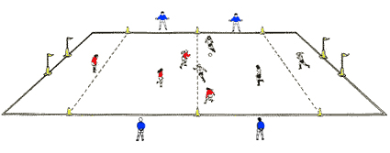
- Game is played in area 25 x 35 yards
- Goals are 4 yards wide and 5 feet high (corner flag height)
- 3 teams of four players
- Goalkeeper may use hands only within six-yard area.
- Rotate goalkeepers on an equal-time basis.
- The "windows" on the outside of the field play with the team in possession.
- The "windows" come on to the field when a goal is scored or at the discretion of the coach - of no goals are scored.
- It is in the interests of the "windows" to help score a goal as they then come on to the field at the expense ofthe team that is scored on.
- Therefore encourage the "windows" to play low balls from the outside to the central area in front of the goals - the beginnings of the cross ball.

So the first practice could be used as early as 7 years of age and moderated and progressed through their years.
In the next practice, the Medium Mixed Bag, we are moving into more "formal" attacks from the flanks with a neutral crosser or two on each outside channel. 2 strikers vs. one defender and a goalkeeper produce the classic near and far post runs.
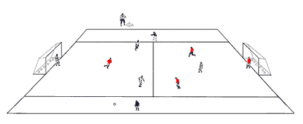
This practice would be suitable for players from age 9 or 10 and can once more be progressed in terms of numbers and difficulties from there on in. At this age it would be important to rotate the players so that most, if not all, get experience in different roles and situations.
Finally after developing the Medium Mixed Bag in field size and numbers we could arrive at the "full" Mixed Bag that we've shown in an earlier newsletter.
The Mixed Bag practice can be modified and progressed in many ways - including the introduction of 2 vs. 1 in the channels. This is the "stuff" of the game - crossing, shooting, headed clearances, great saves. If players don't enjoy this they shouldn't be playing.

Keep Away 6 vs. 1

Objectives:
To encourage players from an early age to appreciate the benefits of passing the ball to a team-mate; to make the possession game directional with penetrating passes.
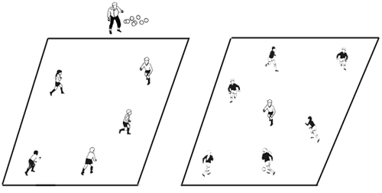

Organization:
- Mark two grids 15 x 15 yards depending on numbers, 3-yards apart.
- Assuming there are 10 to 12 players split group in half, say two groups of 6.
- Use pinnies to distinguish the two groups.
- One group of 6 goes into a square and just one of the other group also goes into the same square. The other five go into the other square.
- The 6 players try to keep the ball away from the one defender.
- After three passes they are allowed to pass the ball to the other square. If they do and it is a good pass to the other square they score a point (Coach to act as referee).
- If defender wins the ball or forces the team in possession to play a poor pass into the other square or out of play he/she scores a point for their team.
- When the ball is passed to the other square the former defender runs across to join his/her team-mates and one of the other team runs over to become a defender.
- Similarly, if a mistake is made the defender joins his/her team together with the other team's defender and the coach plays in a ball.
- Defending chores shared on equal time basis.
- Team that scores the most points is the winner.

Teaching:
- Coach must assess whether playing area is too big or too small and make adjustments.
- For the first few minutes allow players to play in a non-competitive way. When a mistake is made, the coach can recreate the situation and then ask the player who made the mistake what the alternatives are. Praise him or her for the answer if it is a good one.
- After a few minutes go into the competition, but tell the players they don't have to play into the other square after three passes unless it is a good time to do so. They can keep possession and pick their time.
Challenge:
- To score more points than the opposing team by good passing and support or by good defending.

Spinning Wheel

Objectives:
To develop the techniques of turning with the ball when back is to the goal to improve accuracy and weighting of the pass. Can be used as a Warm-Up activity.
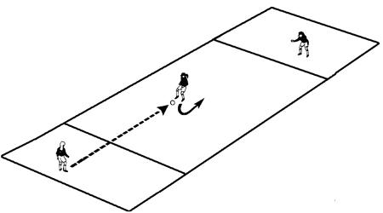
Organization:
- Set up several areas, having groups of three players as shown.
- Each playing area is 20 yards long and 5 yards wide and sectioned into three. Two end 5 yard square boxes and one 10 x 5 yards center box.
- Play starts at one end. Ball is played to middle player, who turns with ball and plays it to teammate at other end.
- End player may control ball or play it first time back to middle player, who turns and plays it to third player with no more than two touches.
- All players must play ball from within their respective boxes.
- Teams count each time the ball is played across, but does not count if the ball goes over sidelines, or if it is not played from within the respective boxes.
- Winning team is one with most successful crosses in one minute (stop watch out!)
- Change middle player with one of the end players and repeat game.
- Add light defending (defender cannot take the ball) as players progress in their ability to turn quickly with control of the ball.

NOTE: A key to success is the middle player's ability to turn quickly.

Teaching:
- At first do not make it a competition so they can practice and experiment.
- Condition it for some time; turning with inside of the foot; or outside of the foot, step-over turn, etc.
- When competition starts - turn any way; turn using inside foot only; outside of foot only ─ at the direction of the coach, etc (ball must be under control at all times).
- Asking for the ball to a specific foot and having the end players pass to the right or left of the middle player.

Challenge:
- To make turns which protect the ball and passes which have good pace.

