OBJECTIVES OF THE SESSION - WEEK 2 – Turns and intro to receiving
Skills development
- Turning the ball to avoid a defender
- Using the bottom of your foot to control your dribbling
- Receiving a ball on the ground and controlling the ball followed by a quick turn
Game savvy
- Drag and step-over turn
- Attacking one-on-one to get behind the defense
Magic Moment
- Change of pace with the ball – stutter move (slow ball down and then accelerate quickly forward)
- Change direction – Feint left and right (fake going left and push the ball to the right with the outside of your right foot)
60-minute session
The first ten minutes of fun, unpressured time is left between children and their imagination. Set up a field with no goals and place 4 balls (half the number of players on the team) in the field. Make the field large to allow for kids to explore open space. Tell the kids to play keep away (each player for him or herself).
Let’s go! (10 minutes)
- Dribble through the Jungle from week one – at a cone player performs a fake or turn from the homework
- Knock the Jungle down - players knock down a cone with their foot on top of the ball and then drag the ball away from the cone in a new direction – as the coach keep the jungle reforested as the kids dribble.
Time out!
- Water break
Here we go again! (20 minutes)
- Relays – vary how they dribble around a cone and back – inside right / left, outside right / left…. (See Figure 2 below)
- Spinning Wheel – See Figure below)
Half-Time!
- Water break
The Adventures Continue! (15 minutes)
- 1 v 1 to targets: Spinning Wheel with a defender. Player receives a ball turns and tries to beat a defender and pass the ball to the target player on the other side – rotate D and O as the ball leaves play.
The Game!!!! (4 v 4 to two goals – let them play – 15 minutes)
Fun (Home) work!
Homework for next week – turns (i.e. drag) and fakes.

Spinning Wheel

Objectives:
To develop the techniques of turning with the ball when back is to the goal to improve accuracy and weighting of the pass. Can be used as a Warm-Up activity.
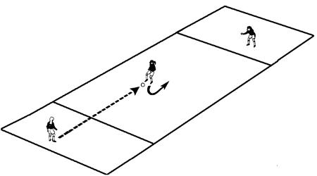
Organization:
- Set up several areas, having groups of three players as shown.
- Each playing area is 20 yards long and 5 yards wide and sectioned into three. Two end 5 yard square boxes and one 10 x 5 yards center box.
- Play starts at one end. Ball is played to middle player, who turns with ball and plays it to teammate at other end.
- End player may control ball or play it first time back to middle player, who turns and plays it to third player with no more than two touches.
- All players must play ball from within their respective boxes.
- Teams count each time the ball is played across, but does not count if the ball goes over sidelines, or if it is not played from within the respective boxes.
- Winning team is one with most successful crosses in one minute (stop watch out!)
- Change middle player with one of the end players and repeat game.
- Add light defending (defender cannot take the ball) as players progress in their ability to turn quickly with control of the ball.

NOTE: A key to success is the middle player's ability to turn quickly.

Teaching:
- At first do not make it a competition so they can practice and experiment.
- Condition it for some time; turning with inside of the foot; or outside of the foot, step-over turn, etc.
- When competition starts - turn any way; turn using inside foot only; outside of foot only ─ at the direction of the coach, etc (ball must be under control at all times).
- Asking for the ball to a specific foot and having the end players pass to the right or left of the middle player.

Challenge:
- To make turns which protect the ball and passes which have good pace.

Relays With and Without the Ball

Players young and old always enjoy the challenge and fun of relays. It is an old standby, but it works. While winning and losing should be downplayed most children enjoy a relay challenge, but make sure the “winning” aspect is not overdone at the younger ages.
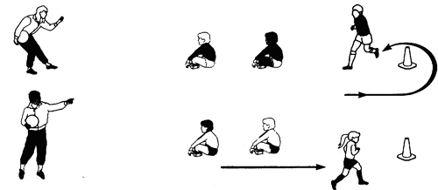

- Use a variety of relays – players perform a turn at the last cone instead of dribbling around it (examples).
- Drag turn
- Step-over turn
- Use your imagination fun turn
- Give a point for each success. For a tie or close to a tie – a point each.
- Team scores are what counts.
- Try to keep numbers per relay group to three maximum – for greater activity.
- Try to have the players exchange a ball that is moving with either a take-over or by passing from the last cone to the next player in line.

