OBJECTIVES OF THE SESSION - WEEK 1 – 1 V 1 DRIBBLING
Skills development
- Running and dribbling with the ball to beat a defender
- Using the inside and outside of both feet
- Receiving a ball on the ground and controlling the ball while moving forward – don’t stop the ball
Game savvy
- Taking space on the field (where is the space)
- Attacking one-on-one to get behind the defense
Magic Moment
- Change of pace with the ball – stutter move (slow ball down and then accelerate quickly forward)
- Change direction – Feint left and right (fake going left and push the ball to the right with the outside of your right foot)
60-minute session
The first ten minutes of fun, unpressured time is left between children and their imagination. Set up a field with no goals and place 4 balls (half the number of players on the team) in the field. Make the field large to allow for kids to explore open space. Tell the kids to play keep away (each player for him or herself).
Let’s go! (10 minutes)
- Dribble through the Jungle (see Figure 1 below)
- Knock the Jungle down followed by reforest the Jungle
Time out!
- Water break
Here we go again! (20 minutes)
- 1 v 1 to a cone – pair players off giving each a ball and a cone. Have them place the cone anywhere on the field and have the dribble to knock over the cone. The player who hits the cone the most wins – rotate pairs if needed. Play for about 45 sec and stop players to introduce a move. Do this 2 or 3 times.
- Relays – vary how they dribble around a cone and back – inside right / left, outside right / left…. (See Figure 2 below)
Half-Time!
- Water break
The Adventures Continue! (15 minutes)
- 1 v 1 to a line (play in a small grid with a players scoring a point by dribbling the ball past the defender and stopping the ball on a line instead of shooting into a goal – requires more control and doesn’t reward players who just kick to the goal as fast as possible). Play is started by the defender passing to the offensive player who must control the pass.
The Game!!!! (4 v 4 to two goals – let them play – 15 minutes)
Fun (Home) work!
Homework for next week – turns (i.e. drag) and fakes.

Dribble through the Jungle
Organization
- Make an area using marker disks, cones, etc.
- One ball per Child.
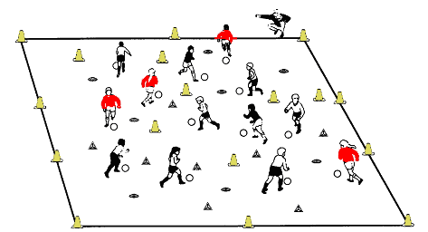
Games and variations
- All the Children must dribble the ball through the jungle without touching a tree (poisonous).
- They may be chased by lions, tigers or elephants (coaches).
- They can "clear" the jungle by knocking down the cones with the ball (Knock the Jungle Down)
- Cones are poisonous and cannot be knocked down with feet...only by kicking the ball against the cone.
- Later reforest the jungle by putting the trees (cones) back up (Reforest the Jungle), using only our feet (seedlings/non-poisonous!) and not our hands (little bit poisonous!). Use your imagination to spark the imagination of the Children.

Relays With and Without the Ball

Players young and old always enjoy the challenge and fun of relays. It is an old standby, but it works. While winning and losing should be downplayed most children enjoy a relay challenge, but make sure the “winning” aspect is not overdone at the younger ages.
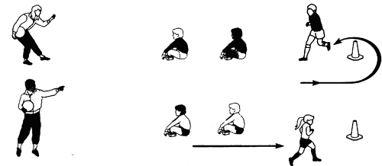

- Use a variety of relays (examples).
- Dribble around cones with right foot
- Dribble around cones with left foot
- Use both feet inside of foot only
- Use only the bottom of your foot.
- Race to place ball on line, touch the next player and they have to retrieve it, etc., etc., etc.
- Give a point for each success. For a tie or close to a tie – a point each.
- Team scores are what counts.
- Try to keep numbers per relay group to three maximum – for greater activity.
- Try to have the players exchange a ball that is moving with either a take-over or by passing from the last cone to the next player in line.

